Name: Date:
Name of Doctor/Nurse:
Be active
Reduce your risk of type 2 diabetes
For some people, making small changes to your lifestyle, including being active, eating well and maintaining a healthy weight, can be effective in reducing the risk of type 2 diabetes by about 50%. This information sheet gives you some tips to help you get more active.
What are the benefits of activity?  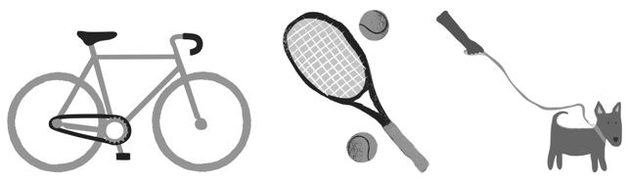  As well as reducing your risk of type 2 diabetes, getting active can help you feel less stressed, sleep better and stay more mobile. Doing just a little bit more, every day,  will make a big difference to your health. | How much activity?  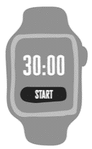  Ideally, aim for at least 150 minutes a week of moderate intensity activity. This could be done by doing at least 30 minutes of activity five times a week.  Activities like walking fast and cycling all count. Add some activity that strengthens your muscles, like digging in the garden or yoga twice a week. Remember, doing any amount of activity is better than none.

Top tips to getting active
- Start slow. Your muscles will get stronger  with time.  - Make small changes to your daily life.  Walking is free and a great way of getting fitter. Enjoy a walk in your local park, get off the bus a stop early or leave the car at home for small trips. You may want to plan ahead if you have mobility issues. For example, add rest stops or check wheelchair accessibility.  - Get a pedometer (step counter) or use an app.  You can set yourself fun challenges, like adding more steps to your normal activity level, and see this increase over time.  - Get fit with friends. Instead of meeting friends for a coffee or to watch TV, go for a walk in the park, visit the shops, play a sport like bowls or golf, or hit the dancefloor. | - Sit less and move more. Get up and walk around every 30 minutes and try standing whilst watching  TV or on the phone. There are also chair-based exercises you can do, if standing is difficult.  - Keep it interesting and fun. There are so many activities to choose from. Try and find new activities that you might enjoy.  - Ask about local support. Many areas have walking groups or free exercise sessions. Diabetes UK also have information and free workout videos on their exercise webpages.  - Don’t give up. Although your body benefits as  soon as you become more active, you may not  see changes straight away. It can take time for your body to get used to the activity, so keep going and set goals that are right for you.

Agreed action plan
My personal goal is:
To be achieved when:
The two steps that I will take to achieve this are:
(Discuss and agree with your doctor or nurse. Think about what, where, when and how?)
1
2

