Name: Date:
Name of Doctor/Nurse:
Diabetes and blood pressure
Information prescription
Your last blood pressure reading is
People with diabetes and high blood pressure are at increased risk of having a heart attack or stroke. By lowering your blood pressure, you can dramatically reduce your risk.
Recommended target for blood pressure is lower than

What does blood pressure mean?  It’s the force your heart needs to push blood around your body. The two numbers show the biggest force your heart uses to push your blood and the least pressure when your heart has relaxed. | Your doctor will advise on the best medications  for you. You'll need to have your blood pressure checked to see how well it is working. Most  people don't experience side effects. If you do  it's important to tell your doctor.
Blood vessel  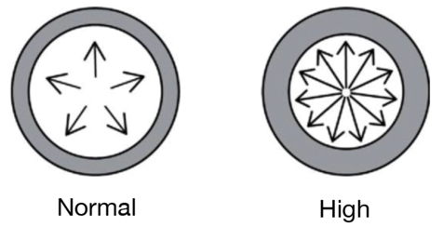  When is high blood pressure a problem?  High blood pressure (sometimes called hypertension) is when the force used to push blood around your body is normally higher than recommended. High blood pressure puts more strain on your heart and blood vessels. If you have high blood pressure, you may feel healthy, but it is causing damage to blood vessels.  How can I lower my blood pressure?  Getting support to make lifestyle changes has been proven to reduce blood pressure and make you  feel healthier. Most people with diabetes will need medication as well. Some people require more than  one type of medicine. | Get support to manage your weight  If you are living with obesity or overweight, ask about a referral to your local weight management groups.  Eat a healthy balanced diet  Reduce salt: eat less fast food, choose low-salt options, and do not add salt.  If you drink, cut down on alcohol.  Eat plenty of vegetables and fruit - aim for at least five portions a day.  Eat less fatty foods, processed meats, pastries  and cakes.  Aim for at least two portions of oily fish a week.  Get more active  Aim for 150 minutes a week to raise your heart beat. Activities like walking fast and cycling all count. Add some activity that strengthens your muscles, like gardening or yoga, twice a week.  Stop smoking  For help giving up ask for your free NHS local Stop Smoking Service.

Agreed action plan
My personal goal is:
To be achieved when:
The two steps that I will take to achieve this are:
(Discuss and agree with your doctor or nurse. Think about what, where, when and how?)
1
2
Date to be reviewed:

