Name: Date:
Name of Doctor/Nurse:
Diabetes and bad cholesterol
Information prescription
Your last cholesterol reading is: Total HDL
People with diabetes and high levels of bad cholesterol are at higher risk of having a heart attack or stroke. By lowering your bad cholesterol, you can dramatically reduce your risk.

What is cholesterol?  Cholesterol is a type of fat in the blood. Sometimes it is called lipids. There is good cholesterol and bad cholesterol. HDL (high-density lipoprotein) is good cholesterol which helps protect you from heart disease. Both triglycerides and LDL (low-density lipoprotein) are bad for you. | Most people need a medication to lower their bad cholesterol – the most common is a statin. These  have been proven to lower cholesterol. Most people don’t experience side effects. If you do it’s important to speak to your doctor so they can find a medication that suits you.
Blood vessel  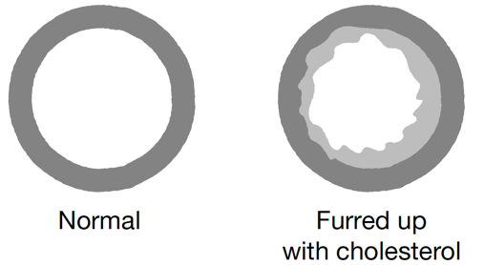  When is cholesterol a problem?  Too much bad cholesterol in the blood causes fatty material to build up in the blood vessels supplying the brain and heart, making them narrower. This can lead  to a blockage in blood vessels, which can cause a  heart attack or stroke.  How can I lower my cholesterol?  You can get support to make changes that lower your  risk of having a heart attack or stroke. The next column explains how. | Get support to manage your weight  If you are living with obesity or overweight, ask about a referral to your local weight management groups.  Eat a healthy balanced diet  Eat less fatty foods, processed meats, pastries  and cakes.  Include wholegrains, such as oats or barley,  and pulses.  Plain nuts or unsweetened yogurt are healthy  snack options.  Aim for at least two portions of oily fish a week.  Eat plenty of vegetables and fruit – aim for at least five portions a day.  Replace butter, lard and ghee with vegetable oils  and spreads.  Get more active  Aim for at least 150 minutes a week of moderate intensity activity. This could be done by doing at least 30 minutes of activity five times a week. Add some activity that strengthens your muscles, like gardening or yoga, twice a week.  Stop smoking  For help giving up ask for your free NHS local Stop Smoking Service.

Agreed action plan
My personal goal is:
To be achieved when:
The two steps that I will take to achieve this are:
(Discuss and agree with your doctor or nurse. Think about what, where, when and how?)
1
2

