Name: Date:
Name of Doctor/Nurse:
Diabetes and your feet
Information prescription
Your foot risk is: Moderate High
People with diabetes are at higher risk of developing serious foot problems, including ulcers and infections. These could lead to amputations and increase your risk of a heart attack and stroke.
By managing your diabetes and looking after your feet you can reduce your risk of foot problems.
What you should know about your feet  and diabetes  - Diabetes can damage the blood flow to your feet.  - Diabetes can damage the nerves in your feet, changing the way you feel things.  - High blood glucose (sugar) also increases the risk that any wounds or ulcers could become infected.  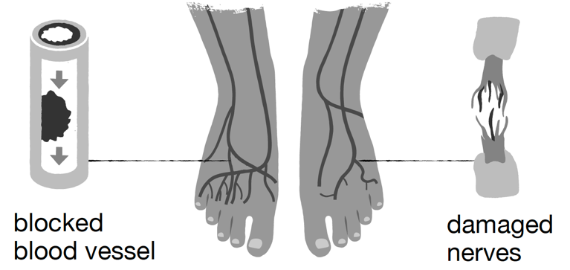  When do you have a foot problem?  The damage to nerves or blood flow can cause numbness, burning, dull ache or changes in the skin.  If this happens, see your GP or podiatrist. However if you develop changes in the shape, colour or temperature or notice a wound you didn’t know was there, see your local foot team urgently.  How do you keep your feet healthy?  Get to know what’s normal for your feet. Remember, if  you lose feeling in your feet you might not be able to feel damage - no pain isn’t a sign that it’s not serious. | Smoking  Smoking makes it harder for blood to flow around your body. For help giving up, ask for your free NHS local Stop Smoking Service.  Look after your diabetes  Keep your blood sugar, cholesterol, and blood pressure at safe levels. Talk to your doctor or nurse about your latest results and what your personal targets should be.  Ask about local diabetes courses.  Eat a healthy balanced diet and stay active  Lifestyle changes could help manage your diabetes. Some activities can increase the risk to your feet, so discuss new ways to get active with your clinician.  Look after your feet  Check your feet daily or ask for help if you can’t.  Look after toe nails – not too short or long.  Wear shoes and socks that don’t rub – get your feet measured to check the fit of shoes.

Safety note
Check your feet every day for:
- broken skin, cuts or blisters that don’t heal
- red, hot, swollen foot or toe
- colour changes
- new pain
If you notice any of these changes contact your local foot team within 24 hours as these can become serious problems very quickly. Please ask your healthcare professional to fill in the contact number.
Call:

Agreed action plan
My personal goal is:
To be achieved when:
The two steps that I will take to achieve this are:
(Discuss and agree with your doctor or nurse. Think about what, where, when and how?)
1
2

