Name: Date:
Name of Doctor/Nurse:
Diabetes and high HbA1c
Information prescription
Your last two HbA1c results are / / / /
Managing you blood glucose is important to reduce your risk of the long term complications of diabetes. Discuss and agree with your doctor or nurse your ideal target for HbA1c.
My recommended target HbA1c is:
What is HbA1c?  It tells you your average blood glucose for the last two to three months. HbA1c measures how much glucose is stuck to your red blood cells. A finger-prick test shows you a snap-shot of your glucose at a moment in time, whereas HbA1c acts like a film recording how your glucose levels have changed.  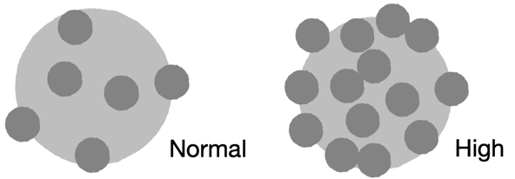  When is high HbA1c a problem?  High levels of blood glucose over a long period of time  can damage blood vessels, putting you at higher risk of  the long term complications of diabetes such as sight loss, kidney damage and heart attack or stroke.  How can I lower my HbA1c?  Your HbA1c will change for many reasons including: being unwell, stress or depression, change in lifestyle or because of other medicine such as steroids. The actions you take to reduce your HbA1c will depend on whether you have type 1 or type 2 diabetes and your overall health. The next column has three main areas for you to consider.  Some people with type 2 diabetes have put their type 2 diabetes into remission (when blood sugar levels are below  the diabetes range for at least 3 months), by losing a substantial amount of weight – 15kg (or 2 stone 5lbs) – safely and as quickly as possible following diagnosis. Remission of type 2 diabetes means glucose lowering medication is no longer needed. Ask your healthcare team for more information. | 1 Education:  You should be offered education to help you manage your diabetes and help you understand what affects your blood glucose. Ask what’s on offer in your area.  2 Medication:  It may be time for a review by your health care team of your medication to be sure it’s best for your individual needs.  3 Lifestyle:  Discuss what changes can lower HbA1c:  Keep to a healthy weight  Work with your healthcare team to find a weight loss plan that you enjoy and fits in with the rest of your life.  Eat a healthy balanced diet  Choose healthier sources of carbs such as wholegrains, fruit and veg, unsweetened milk and yogurts. All carbohydrates affect blood glucose levels so you may need to eat less.  Cut down on free sugars, red and processed meats and choose healthier fats.  If you drink, keep your weekly alcohol intake to 14 units or less.  Aim for at least two portions of oily fish a week.  Get more active  Ideally, aim for at least 150 minutes a week of moderate intensity activity. This could be done by doing at least 30 minutes of activity five times a week. Add some activity that strengthens your muscles, like gardening or yoga, twice a week.  Stop smoking  If you smoke ask for your free NHS local Stop Smoking Service for help giving up.

Agreed action plan
My personal goal is:
To be achieved when:
The two steps that I will take to achieve this are:
(Discuss and agree with your doctor or nurse. Think about what, where, when and how?)
1
2

