Name: Date:
Name of Doctor/Nurse:
Type 2 diabetes remission
Information prescription
My last two HbA1c results were on / / on / /
My weight was on / / , I’m aiming for on / /
If you are living with obesity or overweight, research shows it is possible to put type 2 diabetes into remission by losing a substantial amount of weight quickly. Even if your diabetes does not go into remission, there are still huge benefits to losing this amount of weight and then keeping that weight off.
What is type 2 diabetes remission?  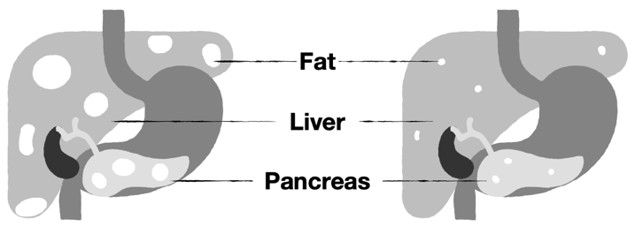  When your blood sugar levels are below the diabetes range without needing to take any diabetes medications. This is when your HbA1c – a measure of long-term blood glucose levels – remains below 48 mmol/mol or 6.5% for at least 3 months without glucose lowering medications. To have the best chance of remission, aim to lose substantial amount of weight (about 15kg/2.5 stones) safely and quickly as possible following your diagnosis.  This weight loss removes harmful fat from the liver and pancreas, which research suggests is linked to remission.  Remission is not a cure or quick fix and long-term lifestyle changes are needed to maintain your weight loss and  keep your diabetes in remission. You need to keep going to your diabetes reviews and eye screening each year to check your diabetes is still in remission and you are free from complications.  What are the benefits of remission?  Remission can be life changing. You could:  - be free from diabetes symptoms and the need to manage your diabetes  - stop taking diabetes medications  - reduce your risk of diabetes complications  - improve your quality of life and overall health | Can everyone who loses a substantial amount of weight achieve remission?  Not everyone who loses weight will be able to put their diabetes into remission and researchers are working out why. There are still benefits to losing weight:  - Reduced risk of diabetes complications.  - Taking fewer medications.  - Better mental well-being.  - Improved mobility, energy and sleep.  How can I work towards putting my diabetes into remission?  Strong evidence for remission comes from following a nutritionally balanced low-calorie weight management programme (around 850 calories) or having bariatric surgery. Both involve long-term behaviour change.  But there are different ways to lose weight and it’s important to find the right approach for you.  Talk to your healthcare team about services available in your area to support you to lose weight and maintain weight loss.  Access information and tips on losing weight www.diabetes.org.uk/info-weight.  Safety note  Talk to a healthcare professional before you begin any intensive weight loss plan. Also, check if you need to reduce or stop any medications before you begin losing weight. Rapid weight loss is not advised if you are under 18, pregnant, breastfeeding or have ever been diagnosed with an eating disorder.

Agreed action plan
My personal goal is:
To be achieved when:
The two steps that I will take to achieve this are:
(Discuss and agree with your doctor or nurse. Think about what, where, when and how?)
1
2
Always use Information Prescriptions and set action plans in consultation with a healthcare professional

